# Farido’s Restaurant

# Farido's Restaurant Application

**Author**: Saed Hamad

**Date**: 7/8/2024

#### Executive Summary

This project report details the development of Farido's Restaurant application, created using MySQL server and pure Python. The application manages restaurant operations efficiently and includes features such as order processing and report generation.

#### Introduction

Farido's Restaurant application is designed to streamline restaurant management tasks, including order processing, inventory management, and report generation. The application leverages MySQL for database management and Python for backend processing.

#### Requirements

The application requires the following Python packages:

* mysql
* tkinter
* reportlab
* random
* itertools

#### Installation

To install the necessary packages, run the following commands:

1. pip install mysql
2. pip install tkinter
3. pip install reportlab
4. pip install random
5. pip install itertools

#### Methodology

The development process involves setting up a MySQL database to store restaurant data and using Python to interact with this database. The GUI is built using tkinter, while reportlab is used for generating reports.

#### Features

* **Order Processing**: Handles customer orders and updates inventory.
* **Report Generation**: Generates sales and inventory reports.
* **User Interface**: Simple and intuitive interface using tkinter.

#### Results

The application successfully manages restaurant operations, providing an efficient way to handle orders and generate reports.

#### Discussion

The application’s functionality meets the initial project requirements. Future improvements could include adding more features such as user authentication, reservation management, and more detailed analytics.

#### Conclusion

Farido's Restaurant application is a robust solution for managing restaurant operations. It simplifies order processing and provides valuable insights through report generation.

#### Appendices

* **Photos**:

Home Page:

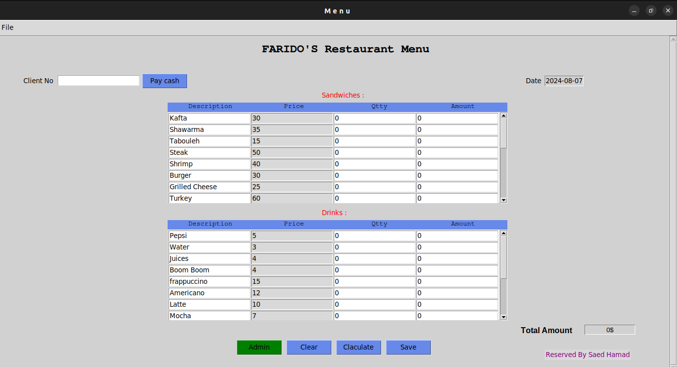

New order:

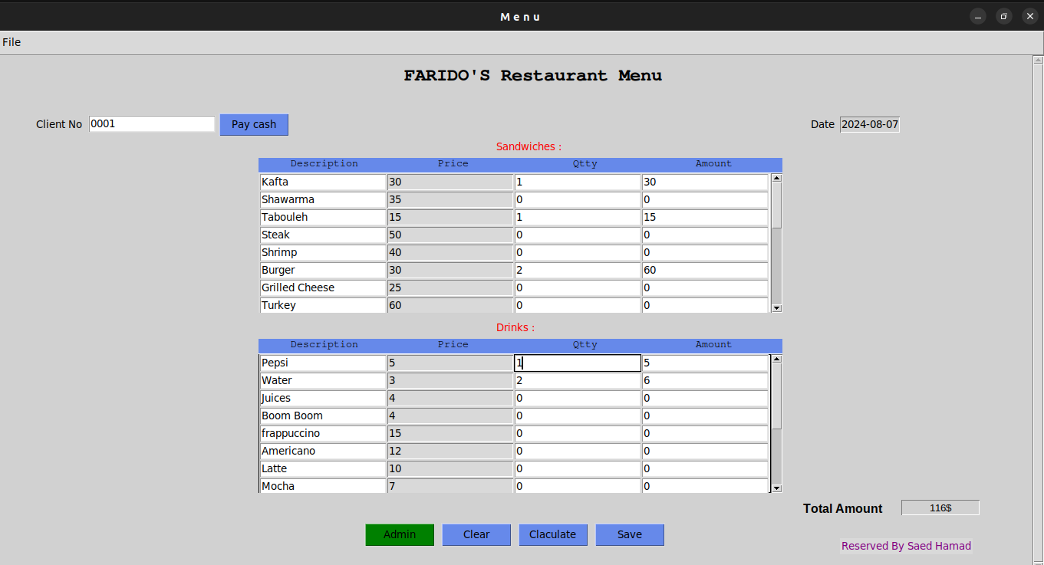

Paycash :

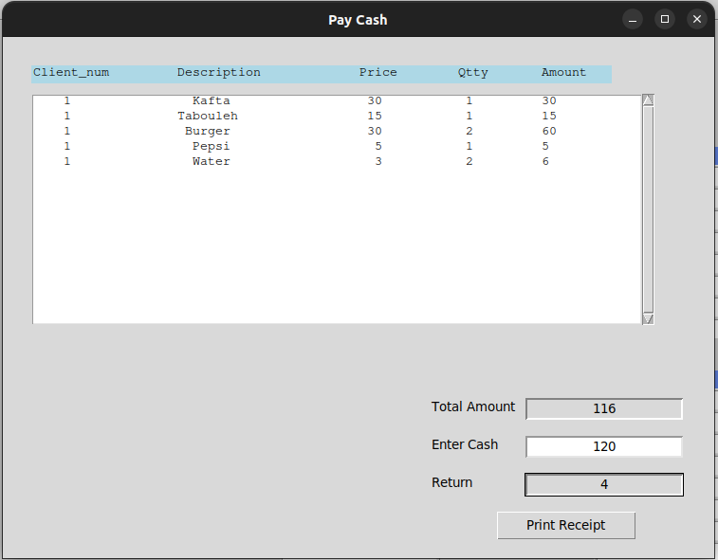

Print reciept :

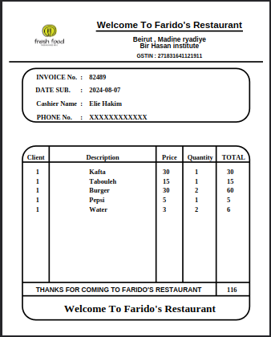

Admin panel after login:

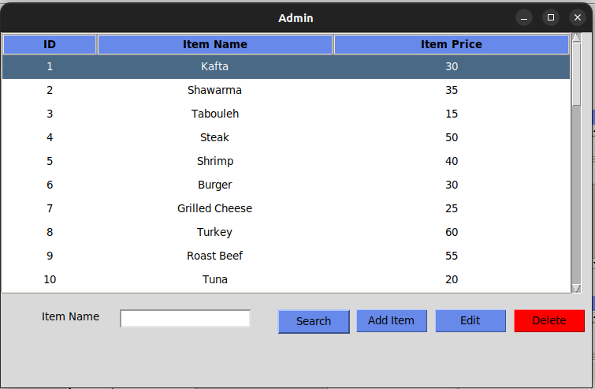

Add item:

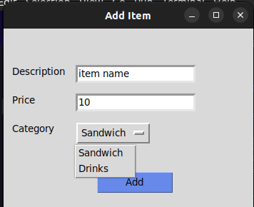

This application was made from scratch. Didn’t used any AI and auto code. Full front and backend validations!!

Hope you enjoy it. Give me your feedback and it's still under develop.